

HACETTEPE UNIVERSITY DEPARTMENT OF
ELECTRICAL AND ELECTRONICS ENGINEERING
ELE 402 - GRADUATION PROJECT II FINAL REPORT

PROJECT TITLE:
Development of Dynamic Arm Support for
children with Duchenne Muscular Dystrophy

PROJECT GROUP MEMBERS:
Yunus Emre TORUN /21428451
Barbaros Orhun ÇAÇAMER /21128014
Ilgaz ARSLAN /21328763

PROJECT SUPERVISOR:
Prof. Dr. Atila YILMAZ

ABSTRACT
This paper reviews the exoskeleton robot device for rehabilitation of Duchenne
Muscular Dystrophy (DMD). There is not exist much research about this topic in Turkey and the number of patients is high enough. Because of this high number,
therapists need this type of robotic device. Also, DMD patients should undergo therapy
frequently than other stroke diseases. Due to several reasons, these patients may not
go to rehabilitation frequently. So, this project has given us from the Department of
Physical Therapy and Rehabilitation. DMD is the most common neuromuscular disease
in childhood with a live male birth rate of 1/3500. This disease, which is caused by the
non-production of dystrophin protein, causes progressive muscle damage, loss of
muscle strength and function. Although there is no treatment currently, the average life
expectancy with symptomatic treatments increases to 30 years of age. The number of
DMD patient populations with wheelchair-bounded limited to daily life activities such as
personal care and dressing due to progressive weakness of upper extremity increases
with increased life expectancy. Due to the nature of the proximal muscle weakness of
the disease, it loses its function of lifting the arm at an average age of 13-15 years.
The main purpose of this project is to design a rehabilitation device used to observe how rehabilitation can help prevent the progression of this disease. The designed orthosis has 3 degrees of freedom. This orthosis is intended to perform elbow, wrist flexion/extension and abduction/adduction movements. DC motors with high torque/weight ratio are used to create the required movements. During the research, several sample design ideas are generated and shown in this report. The main limitation of the design is wearability and attention has been drawn. The material used in the design is 3D printer materials, which means they are plastic. The cable-operated method used for the torque transfer method.
The main advantage of this design is it has supporting capabilities. Instead of
monotonic movements, with this device, we can only help the patient whenever he/she
needs. This is the most crucial necessity for this project, because monotonic
movements may help the rehabilitation of patient but the effectiveness of the
rehabilitation not prolonged.

Table of Contents

1. INTRODUCTION 3
2. PROJECT DESCRIPTION 4
3. ENGINEERING STANDARDS AND DESIGN CONSTRAINTS 6
3.1 ENGINEERING STANDARDS 6
3.2 DESIGN CONSTRAINTS 6
4. SUSTAINABLE DEVELOPMENT GOAL 8
5. BACKGROUND 9
5.1 BACKGROUND ACQUIRED IN EARLIER COURSE WORK 9
5.2 BACKGROUND ACQUIRED THROUGH ADDITIONAL RESEARCH 10
5.3 KINEMATIC ANALYSIS 10
Figure 5.3.3: 12
6. ALTERNATIVE DESIGN METHODS 13
6.1 ALTERNATIVE A 13
6.2 ALTERNATIVE B 13
6.3 ALTERNATIVE C 14
7. FINAL DESIGN 15
7.1 MAIN COMPONENTS of DAS 17
7.2 COST ANALYSIS 18
8. COMMENT AND CONCLUSION 18
9. REFERENCES 19

Figure 1: Simple diagram of the exoskeleton robot 6
Figure 2: Range of motion for elbow joint [7] 8
Figure 3: Sustainable Development Goals [6] 9
Figure 4: Marker Position 11
Figure 5: Locations of Angles 12
Figure 5: Relative Elbow Angle 13
Figure 6: Relative Shoulder Angle 13
Figure 7: Picture of prototype A 14
Figure 7: Solidworks Design of Prototype B 14
Figure 8: Solidworks Design of Prototype C 15
Figure 9: Sample of DAS 16
Figure 10: Working Principle of Orthosis and Design Steps 17
Figure 11: Linear Motor (12V-200mm) and Nemo 17 Step Motor 18
Figure 12: HTD 3m Belt and Step Motor Driver A4988 18
Figure 13: Motor Driver L298N and FSR 18
Figure 14: HTD 3m 12&36 Gear 18

INTRODUCTION
Physical therapy is the services provided by physical therapists to individuals and populations to develop, maintain and restore maximum movement and functional ability throughout the life span. The service is provided in circumstances where movement and function are threatened by aging, injury, pain, diseases, disorders, conditions or environmental factors and with the understanding that functional movement is central to what it means to be healthy [1].
Robotic exoskeletons or powered exoskeletons are considered wearable robotic units controlled by computer boards to power a system of motors pneumatics, levers, or hydraulics to restore locomotion [1][2]. The topic of exoskeletons is timely given the number of devices currently being studied as well as purchased by facilities for rehabilitation purposes in medical centers or for home use [3].
The development of robotic exoskeletons already began in the second half of the 20th century. Around 1965, General Electric (in the US) started to develop the Hardiman, a large full-body exoskeleton designed to augment the user’s strength to enable the lifting of heavy objects. The first exoskeletons for gait assistance were developed at the end of the 1960s at the Mihajlo Pupin Institute Serbia, and in the early 1970s at the University of Wisconsin-Madison in the US [4].

PROJECT DESCRIPTION
Our goal in this project is to develop Dynamic Arm Support (DAS) in children with Duchenne Muscular Dystrophy (DMD).
Exoskeletons are wearable devices that work in tandem with the user. Exoskeletons are placed on the user’s body and act as amplifiers that augment, reinforce or restore human performance. The opposite would be a mechanical prosthetic, such as a robotic arm or leg that replaces the original body part. Exoskeletons can be made out of rigid materials such as metal or carbon fiber, or they can be made entirely out of soft and elastic parts. Exoskeletons can be powered and equipped with sensors and actuators, or they can be entirely passive. Our project is for arm support only. However, Exoskeletons can cover the entire body as it can only be for one limb.
Also, this project can be combined with other technology. An example of computer technology (artificial intelligence, remote control with web-based programs), sensor technology, robot technology, and control technology. Our main objective in this project is to rehabilitate wrist, elbow and shoulder joints orthosis is designed to achieve this goal. It is planned to use an EMG sensor in this design, FSR or FSC sensors, gyro for determination of movement angle, DC motor or linear motor to provide movement. MSP430 and Arduino UNO microcontrollers can be used to control these components. The next figure shows the basic flow chart of the orthosis.

Figure 1: Simple diagram of the exoskeleton robot

The arm orthosis is mounted on a plate and fed by an external source.
Actuators that connect the joints between joints. The motion is defined in the system. When the required mode is selected by the user, the system begins to implement the algorithm for the microcontroller unit (MCU) on its own. The MCU receives external analog and digital signals from sensors on the orthosis ADC converter or I2C, USART, etc. with the help of communication methods such as the feedback algorithm makes a decision and strengthens it. When the desired position is determined, the MCU continues to the following position. When the whole operation is done with the orthosis, the system closes itself and powers the brakes on the gears to maintain the position of the orthosis. Therefore, unexpected errors are avoided.

ENGINEERING STANDARDS AND DESIGN CONSTRAINTS

3.1 ENGINEERING STANDARDS
The devices are produced in Turkey and any European Union countries, it must comply with the overall performance and safety standards. The devices produced and distributed in accordance with these standards are CE marked. This CE mark means that the device meets the essential requirements and suitable for the intended use by the manufacturer. At this point, it can be said that the CE mark is the passport of the product. Compliance with the standard of medical devices in Turkey is made by the control of the Ministry of Health.

Turkey’s medical device regulations devices are classified into 4 groups;

- Class I: Usually low risk

- Class IIA: Usually medium risk

- Class IIB: Usually medium risk

- Class III: Usually high risk

According to these standards, our device may be in Class IIA. Because devices with electrically driven equipment for the electrical propulsion (the user is energized) are in the Class IIA [5].

3.2 DESIGN CONSTRAINTS

A) Displaceability:

The described system will be a semi-wearable system. It won’t be able to fully mountable and its position can be chosen by place to place and the functionality of the system will be increased by this transportability property.

- B) Degree of Freedom (Angle Limitations):

As a wearable system, because of the human body limitations, also the system has limits of actions and movements.
The figure shows the limits of arm motions of the wrist, forearm, and elbow. The system design should consider these values as the maximum point of motion and for in case of need, new values (values less than on the table) can be chosen to taking precautions.
Figure 2: Range of motion for elbow joint [7]
C) Torque Necessitations

The system should consider the limitations of the torque generation and also satisfy the minimum torque conditions.
D) Environmental Factors

Power requirements should be specified, also the size and shape of the design should be proper.

E) Medical Factors

Electrical safety and patient discomfort should be considered. That means electric hazards should be minimized and it should not expose the subject to endure pain, discomfort or any other undesirable conditions.

F) Economic Factors
The system should be cost-effective.

SUSTAINABLE DEVELOPMENT GOAL
The Sustainable Development Goals (SDGs), also known as the Global Goals, were adopted by all United Nations Member States in 2015 as a universal call to action to end poverty, protect the planet and ensure that all people enjoy peace and prosperity by 2030

Figure 3: Sustainable Development Goals [6]
Our goal about SDGs is good health and well-being, there are too many DMD patients and there are people who can't use the elbow and arm, these people don't even eat, and similar so many things.

BACKGROUND
Background and literature overview was performed using IEEE Xplore, SpringerLink Journals, PubMed, Google Scholar and Science Direct with keywords combination: active, wearable, orthosis, brace, exoskeleton, elbow. The priority was given to the last 5 year articles.

BACKGROUND ACQUIRED IN EARLIER COURSE WORK

- ELE118 Computers and Programming II
Programming skills are needed.
- ELE361 Electric Machines I
Operating Point Settings
-Torque:
The first basic input based on application motion needs.
-Speed: The second basic input based on application motion needs.
-Voltage: Changing the voltage updates the performance of all motors at the specified
voltage.
-Gearbox: Select gearbox if the application requires high torque and low-speed
combination.
Motor Performance
-Speed: Confirm how critical the motor output speed is for the application. A critical
application, such as a dosing pump, would require the closest possible motor t achieve
the speed and torque target. The percentage of weights should be varied depending on
the importance of the motor speed in the application.
-Efficiency:
If the application is battery powered, efficiency will be a key factor in the motor selection
to maximize battery life. In this case, vary the percentage for efficiency to see the effect
on the list of motor recommendations. If battery life is the most important criterion, set
efficiency to 100% to identify the most efficient motors based on the operating point
selection.
- Power/Current: If the application has a limited budget for power (such as ambulatory
applications), adjust power and current percentages accordingly (i.e. low) to receive
recommendations based on the motors that draw the least amount of power.

Motor Speed Control Methods
Changing the terminal voltage, adding a series resistance, using a potential divider, etc.
Figure 5.1.1 Torque, power and speed conversions
$$Torque\left(N.m\right)=9.5488 x\frac{Power\left(kW\right)}{Speed\left(RPM\right)}$$

BACKGROUND ACQUIRED THROUGH ADDITIONAL RESEARCH

The main movements occurring at the elbow joint are flexion, extension, pronation, and supination. The glenohumeral and radio humeral joints act as a ‘modified hinge joint’ allowing a range of motion from 0° to approximately 145° in the normal patient. Flexion here is due to the action of biceps, brachialis and brachioradialis muscles. The extension is achieved from the action of the triceps muscle located on the posterior aspect of the arm. Supination and pronation occur at the superior radioulnar joint which acts as a ‘pivot’ joint and normal values quoted are approximately 75° pronation and 80° supinations. Supination is achieved through the action of biceps and supinator muscles whereas pronation requires the use of pronator teres, pronator quadratus, and flexor carpi radialis muscles. The forearm is angled slightly away from the long axis of the humerus in full extension. This is known as the ‘carrying angle’ and has a mean angle of 12.7 degrees +/-3.8 degrees. The biomechanics of the elbow joint are all affected by the bones, muscles, and ligaments involved. Weakness in muscle or injury to ligaments can result in abnormal forces in the elbow, which can ultimately over time cause degeneration of the articular cartilage of bone.

KINEMATIC ANALYSIS
A test system was created for kinematic analysis. This test was conducted to determine the angles of movement of the shoulder and elbow. This test was performed with 2 subjects. The movement defined for this test: The hand starts from the vertical position to y plane and comes over the head and returns to its initial position. The following figure represents of marker position.
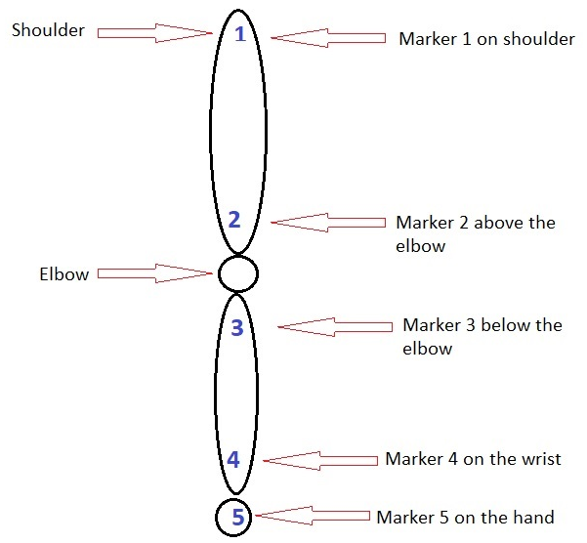
Figure 4: Marker Position
The next figure shows the configuration of the movement in the cartesian system and the locations of the angles to be determined.
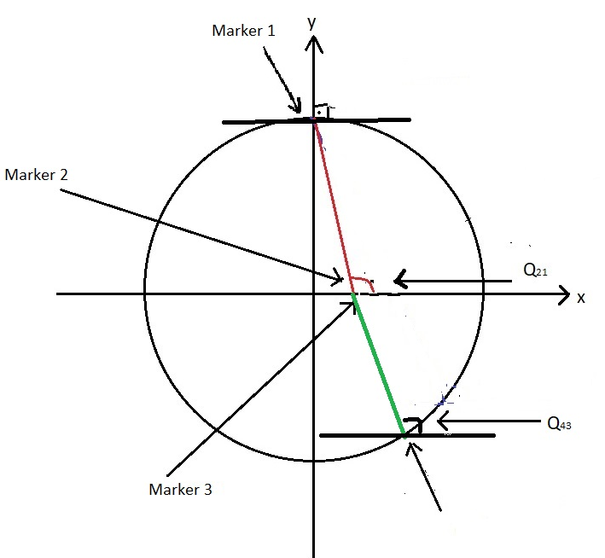
Figure 5: Locations of Angles
The formulas used for calculating angles are as follows:

- Limb-Segment Angle
$θ_{ij}=\tan^{-1}{\frac{y_{j}-y_{i}}{x_{j}-x_{i}}}$
- Joint Angle
$$θ_{k}=θ_{ij}-θ_{ab}$$
- For Shoulder Angle:
$$θ_{k}=θ_{12}$$
- For Elbow Angel
$$θ_{k}=θ_{34}$$
- For Relative Shoulder Angle;
$$θ_{k}={90}^{°}-θ_{12}$$
- For Relative Elbow Angle;
$$θ_{k}=θ_{12}{-θ}_{34}$$

$θ_{12}{>θ}_{34}$ : Elbow is extended
$θ_{12}{<θ}_{34}$: Elbow is flexed
$θ_{k}$ is positive the shoulder plantarflexed; $θ_{k}$ is negative the shoulder is dorsiflexed.
Note: The reference axis is the x-axis. The X-axis is defined as $0^{°}$

Figure 5: Relative Elbow Angle
Figure 6: Relative Shoulder Angle

ALTERNATIVE DESIGN METHODS

ALTERNATIVE A
This prototype is the project of the 2018-2019 period. Developing this prototype was one of our alternatives.
This prototype was materialized by a 3D printer. Joint movements were made with the help of DC motors and ropes. the joint movements of the prototype were not very healthy; In addition, the 3D printer material is not very durable, it carries the risk of breaking. Also, this design did not look as good as the image. On this prototype, it was decided to change the project material and provide one of the movements with a linear motor.
Figure 7: Picture of prototype A

ALTERNATIVE B
In this prototype, shoulder motion is provided by linear motor and elbow motion by servo motor. Aluminum was considered the prototype material. Servo motor being on the elbow caused the linear motor to apply more force. Although it met the requirements, it was not considered adequate and was not implemented in real life.
Figure 7: Solidworks Design of Prototype B

ALTERNATIVE C
In this prototype, the elbow movement was provided by a linear motor, and the step motor was considered to perform shoulder movement. This prototype was prevented by the fact that the linear motor was too heavy, the project frame could not be able to lift the linear motor and did not have the necessary flexibility of movement in the elbow movement. The second prototype was not implemented.
Figure 8: Solidworks Design of Prototype C

FINAL DESIGN
Alternative C was chosen as the final design. This prototype was materialized by the 3D printer and at this stage, a more durable substance was used in the prototype. This orthosis is designed to be mounted on a wheelchair. In this way, the weight of the orthosis will not affect the patient. Linear and step motor are used in this orthosis. Linear motor works with an L298N motor driver also provides shoulder movement. Step motor works with the A4988 motor driver provides elbow movement with the help of gear wheels and belt. Figure 7.1 shows the final design.
Figure 9: Sample of DAS

The next 2 flow diagrams show the working principle and design steps of the orthosis respectively.
Figure 10: Working Principle of Orthosis and Design Steps

MAIN COMPONENTS of DAS

Figure 11: Linear Motor (12V-200mm) and Nemo 17 Step Motor

Figure 12: HTD 3m Belt and Step Motor Driver A4988
Figure 13: Motor Driver L298N and FSR
Figure 14: HTD 3m 12&36 Gear

COST ANALYSIS
EQUIPMENT | COST(TL)
Orthosis Framework | 400
Linear Motor | 262
Nema 17 Step Motor | 80
Belt&Gear | 120
Motor Drivers | 15

COMMENT AND CONCLUSION
The aim of this project is to develop DAS for DMD patients. Solidworks was used in the design part of this project. The designed orthosis was obtained with a 3D printer and Arduino was used to controlling this orthosis. And this Ardiuno also used for communication between sensors and motors.
This prototype supports shoulder and elbow movements. This helps the muscles in the shoulder and upper arms to work. One of the priority objectives of this project has been achieved. Our other goals are to monitoring the patients during rehabilitation and to generate kinematic analyses of the observed movements. The aim of this kinematic analysis is to determine the progress of patients' movements. Studies on this objective are continuing.

REFERENCES
[1] The definition of physical therapy according to World Confederation of Physical Therapy
[2] Joel C. Perry, Jacob Rosen , “Upper-Limb Powered Exoskeleton Design”, IEEE/ASME Transactions on Mechatronics, Vol. 12, No. 4
[3] LIU, Wenlong; YIN, Baolin; YAN, BingBing. A Survey on the Exoskeleton Rehabilitation Rob
for the Lower Limbs. In: Control, Automation, and Robotics (ICCAR), 2016 2nd International Conference on. IEEE, 2016.
[4] Webster, J. G. (ed.), Medical Instrumentation: Application and Design, Fourth Edition, John Wiley & Sons, Hoboken, NJ, 2010
[5]Tıbbi Cihaz Üreticileri İçin Rehber 2006
[6] https://www.tr.undp.org/content/turkey/tr/home/sustainable-development-goals.html
[7] "Elbow Anatomy," [Online]. Available: http://handsport.us/patient-education/elbow-anatomy/. [17.03.2017].

